Competitors Analysis and Advice for Granhub

- https://www.silversurfers.com
- What this project provides：
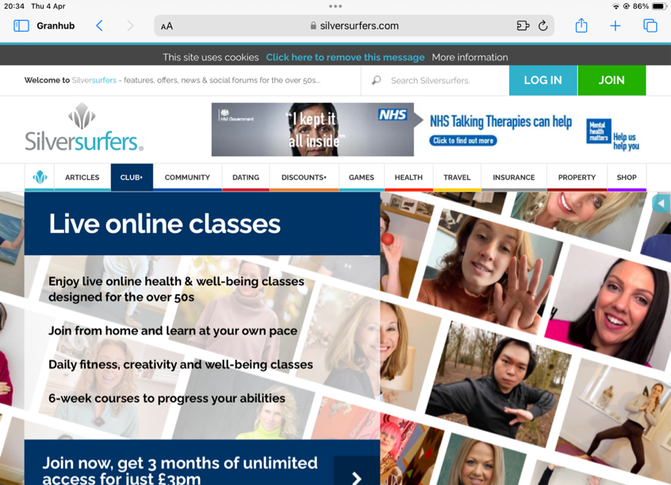
- Articles & Guides: The website provides a wealth of articles and guides covering a wide range of topics relevant to older adults, including health, travel, finance, hobbies, relationship, games and more.
- Forums & Community: SilverSurfers hosts active forums and a thriving community where users can connect, share experiences, ask questions, and offer support to one another.
- Competitions & Offers: Users have access to competitions and special offers, including discounts on products and services tailored to older adults.
- News & Updates: SilverSurfers keeps users informed with the latest news and updates on topics of interest to the older demographic.
- Recipes & Food: The website features a section dedicated to recipes and food-related content, providing inspiration and ideas for meals and snacks.
- Travel Deals: Users can find travel deals and discounts on holidays and vacations, catering to the travel interests of older adults.
- Health & Wellbeing: SilverSurfers offers information and advice on health and wellbeing topics, including tips for staying active, managing health conditions, and maintaining overall wellness.
- Finance & Retirement: The website provides resources and guidance on financial planning, retirement, pensions, and investments, helping users make informed decisions about their finances.
- Entertainment & Leisure: Users can explore entertainment and leisure activities suitable for older adults, including book recommendations, film reviews, and cultural events.
- Technology & Gadgets: SilverSurfers covers technology and gadgets relevant to older adults, with articles and reviews on products designed to enhance their daily lives.

- SWOT Analysis Summary
Strengths:
- Brandy: SilverSurfers website shows that it is a matured and user-friendly and very informative website for over 50s specially for the Citizens in UK.
- Diverse Content: The website offers a wide range of content including articles, forums, and resources covering various topics relevant to older adults.
- Community Engagement: SilverSurfers fosters an active online community through its forums, allowing users to connect, share experiences, and provide support to each other.
- User-Friendly Interface: The website features a clean and intuitive design, making it easy for older users to navigate and access information.
- Partnerships and Collaborations: SilverSurfers may have partnerships with brands, organisations, and advertisers targeting the older demographic, providing additional revenue streams and resources.

Weaknesses:
- Limited Personalisation: The website may lack personalised content recommendations and user-specific features, potentially impacting user engagement and retention.
- Dependency on Advertising: SilverSurfers' revenue model may heavily rely on advertising, which could affect user experience if not balanced carefully.
- Technical Challenges: Older users may face technical challenges or barriers when accessing and using the website, such as compatibility issues with certain devices or browsers.
- Need for Continuous Content Updates: To maintain user interest and relevance, SilverSurfers must consistently update its content and offerings to reflect changing trends and interests among older adults.

Opportunities (which granhub can do in better way)
- Expand Content Offering: SilverSurfers could expand its content to cover emerging topics and trends relevant to older adults, such as digital literacy, online safety, and remote socialisation.
- Enhance Community Features: Introducing new community features, such as live chat sessions, virtual events, or expert Q&A sessions, could further enhance user engagement and interaction.
- Mobile Optimisation: Optimising the website for mobile devices can tap into the growing number of older adults using smartphones and tablets for online activities.
- Partnerships with Local Businesses: Collaborating with local businesses and service providers can offer exclusive deals and discounts to the members, adding value to the platform.
- Health and Wellness Focus: Given the increasing focus on health and wellness among older adults, we could prioritise content and resources related to physical and mental well-being.

Threats:( which granhub could put in mind in the future)
- Changing Demographics: Shifts in demographics or societal trends may impact the size and characteristics of the target audience.
- Technological Barriers: Rapid advancements in technology may pose challenges for older users in keeping up with digital platforms and features.
- Regulatory Changes: Changes in data protection regulations or online advertising policies could affect the operations and revenue streams.
- New competitors entering the market or existing ones expanding their offerings could pose a threat to its market share and relevance.
- Economic Uncertainty: Economic downturns or fluctuations could affect advertising budgets and consumer spending, impacting the revenue.

- Advice for Granhub:
- Focus on User Experience: Prioritise user-friendly design and accessibility features to ensure older users can easily navigate and interact with our website.
- Build a Strong Community: Foster an active and supportive online community through forums, social media engagement, and offline events or meetups.
- Offer Value-Added Services: Consider offering additional services or resources such as online courses, virtual and onsite workshops, travelling events, and useful coupons such as for online shopping or pension schemes or travelling hotels and tickets, or exclusive deals with partner businesses to enhance the value proposition for users.
- Stay Relevant and Responsive: Continuously monitor user feedback, market trends, and technological advancements to adapt and evolve your website's offerings accordingly.
- Diversify Revenue Streams: Explore alternative revenue streams beyond advertising, such as premium memberships, sponsored content, or affiliate partnerships.

- https://www.saga.co.uk
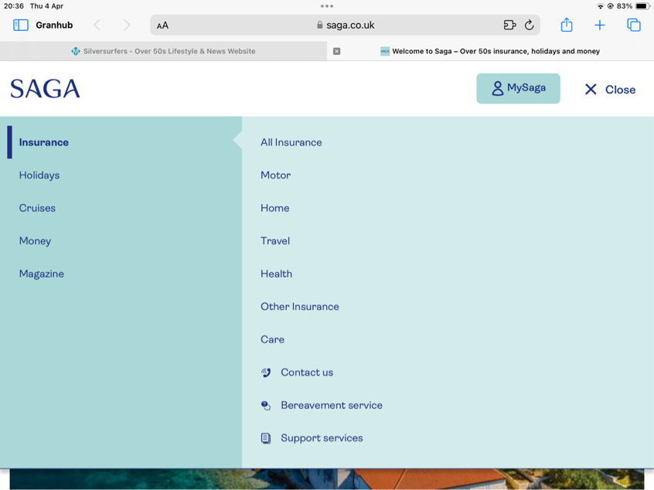
- what this project provides:
- Comprehensive Content: The website offers a wide range of content covering various topics relevant to older adults, including finance, travel, health, lifestyle, and entertainment.
- News and Articles: Saga provides news updates and informative articles on current events, trends, and issues affecting the over-50s demographic.
- Financial Services: Saga offers financial products and services tailored to older adults, including insurance, savings accounts, pensions, and investment options.
- Travel Booking: Users can book holidays, cruises, and other travel experiences directly through the website, with options for both domestic and international destinations.
- Health and Wellbeing Resources: Saga provides information and advice on health-related topics, including articles on medical conditions, healthy living tips, and advice on accessing healthcare services.
- Community Forums: The website hosts online forums where users can connect with each other, share experiences, ask questions, and provide support on various topics.
- Membership Benefits: Saga offers membership programmes with exclusive benefits and discounts for its members, including special offers on travel, insurance, and other services.
- Entertainment and Lifestyle: Users can find entertainment recommendations, lifestyle articles, and leisure activities suitable for older adults, such as book reviews, gardening tips, and recipes.
- Advice and Guidance: Saga provides practical advice and guidance on a wide range of topics relevant to older adults, including legal matters, retirement planning, and care options.
- Customer Support: The website offers customer support services, including FAQs, contact information, and online forms for inquiries or assistance.

- SWOT Analysis Summary
Strengths:
- The main features and contents are similar like other providers
- Good domain: short and easy domain can help the project to do branding and easy to grab the market.
- Clean and neat design: the design looks more simple and professional and make the project looks more reliable and make customer trust in their service quality.
- Membership Programmes: Saga offers membership programmes with exclusive benefits and discounts, providing additional value to users and encouraging loyalty and repeat visits.

Weaknesses:
- Website looks more like a company+platform page: The website purpose is not clear enough, and the design may look too professional for over-50s group to browse.
- Complexity and Navigation: The extensive range of services and content offered by Saga may lead to a complex and overwhelming user experience, with difficulties in navigation and finding relevant information.
- Limited Personalisation: The website may lack personalised content recommendations and user-specific features, potentially impacting user engagement and retention.
4. Technical Challenges: Older users may face technical challenges or barriers when accessing and using the website, such as compatibility issues with certain devices or browsers, affecting user experience.

Opportunities:
Apart from similar opportunities summary like previous one, here would like to add one point we can do membership or club way and cooperate with local community or events holders to provide some benefits for the members would add some good value to maintain a good relationship with the customers and have repeatedly revenue from the existing customers.

Threats:
to grab new market shares or expand the business in this age group, could provide different style sessions for the users, such as AI hi-tech style, fashionable style and family friendly style in different sessions to feed different user tastes.

- Advice for granhub
- Priorirtise one main feature in granhub and design the whole features and demonstrate the website purpose based on that to grab a certain group of people in a faster way such as in Technology, Career, Finance, Housing, Gardening, Parenting, Fashion or anything.
- Embrace digital transformation initiatives, invest in technology infrastructure, and leverage innovations to address technical challenges, improve website performance, and enhance functionality.
- Strategic Partnerships: Forge strategic partnerships and collaborations with complementary businesses, service providers, and brands to offer exclusive deals, discounts, and promotional opportunities, adding value to your platform and driving user engagement and loyalty.

- https://www.ageuk.org.uk/
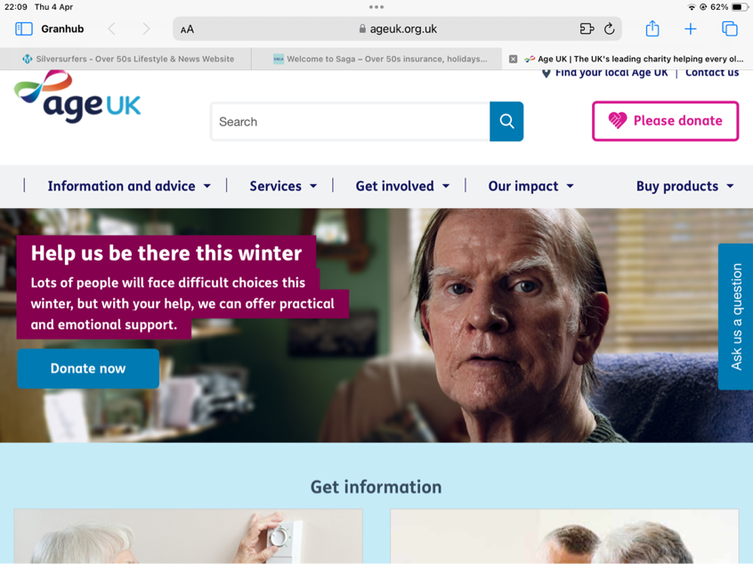

- What they provide
（Charity）
- Information Hub: this provider serves as an information hub providing resources and advice on a wide range of topics including health, finances, social care, and legal matters.
- Services and Support: The website offers various services and support options such as helplines, local directory searches for services, and online tools for assessing eligibility for benefits and support
- Campaigns and Advocacy: AgeUK runs campaigns and advocates for issues affecting older adults, such as loneliness, pension reform, and social care funding. The website provides information on current campaigns and ways to get involved.
- Volunteering Opportunities：Age UK encourages volunteering and provides information on volunteering opportunities across the country, allowing users to get involved in their local communities.
- Products and Fundraising: The website features an online shop selling products aimed at older adults, as well as information on fundraising events and ways to support the charity financially.
- News and Events: Users can access news articles relevant to older adults, as well as information on events such as workshops, seminars, and social gatherings.
- SWOT Analysis Summary
Strengths:
- Well known as a charity brand and leading brand: Age UK is a well-known and respected brand in the UK, with a strong reputation for providing support and services to older adults.
- Comprehensive Services: The website offers a wide range of services and resources, covering various aspects of older adults' lives, from health and social care to finances and legal matters.
- Advocacy and Campaigning: Age UK's advocacy work and campaigns help raise awareness of issues affecting older adults and drive positive change in policies and services.
- Community Engagement: The website facilitates community engagement through volunteering opportunities, local support services, and social events, fostering a sense of belonging and connection among users.

Weaknesses:
- Complexity and Navigation: The extensive range of services and resources offered by Age UK may lead to a complex and overwhelming user experience, with difficulties in finding relevant information and navigating the website.
2. Digital Accessibility: Older users may face challenges in accessing and using the website due to digital literacy barriers, technical issues, or compatibility issues with certain devices.
3. Dependency on Donations: Age UK relies heavily on donations and fundraising efforts to support its operations and services, making it vulnerable to fluctuations in funding and economic downturns.

Opportunities:
1. Digital Transformation: Embracing digital transformation initiatives can improve the website's functionality, accessibility, and user experience, making it easier for older adults to access information and services online.
2. Expansion of Services: Age UK could expand its range of services to address emerging needs and trends among older adults, such as digital inclusion programs, telehealth services, and remote socialisation initiatives.
3. Partnerships and Collaborations: Collaborating with other organizations, businesses, and government agencies can expand Age UK's reach and impact, enabling greater access to resources and support for older adults.

Threats:
similar like other ones such as the technology changing，content need to keep updated more competitor are emerging nowadays

- Advice for Granhub
- Simplify User Experience: Prioritise user-friendly design, navigation, and accessibility features to ensure a seamless and enjoyable experience for older users, enhancing engagement and satisfaction.
- Add AI Chatbox and use AI technology to guide users to use the platform in easier way.
- Expand Service Offerings: Continuously assess and respond to emerging needs and trends among older adults, expanding the range of services and resources offered to meet evolving demands.
- Work with government and charities to add intensive value to the brand to make it more reliable and reputable to the customers.

- https://thirdage.com
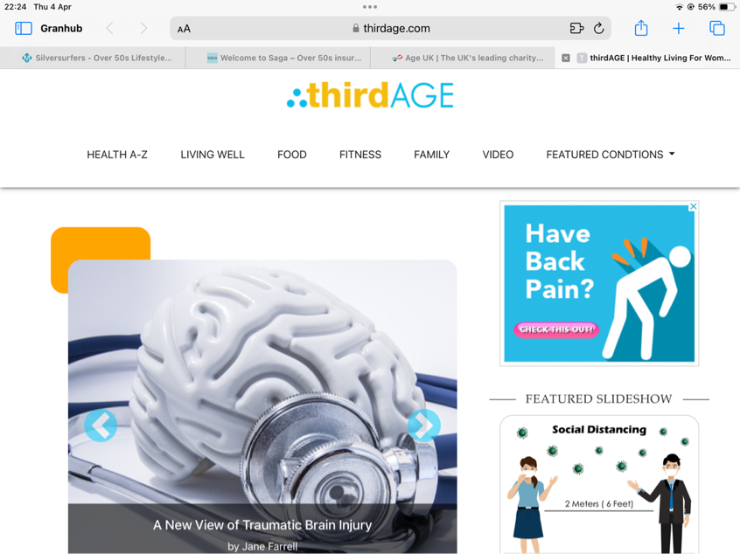
- What they provide:
- Blogs of Articles and Resources: ThirdAge offers a wide range of articles, blog posts, and resources covering topics relevant to older adults, including health, wellness, relationships, finance, and lifestyle.
- Community Forums: The website hosts community forums where users can engage in discussions, ask questions, share experiences, and provide support to each other.
- Expert Advice: Users can access expert advice and insights on various topics, with contributions from healthcare professionals, psychologists, financial advisors, and other experts.
- Newsletter and Email Updates: ThirdAge provides a newsletter and email updates to subscribers, delivering curated content, news, and updates directly to their inbox.
- Social Media Integration: Users can easily share articles and forum discussions on social media platforms, fostering engagement and expanding the website's reach.
- Interactive Features: The website may include interactive features such as quizes, polls, and surveys to engage users and gather feedback.

- SWOT analysis summary
Pros(Strengths/opportunities)
1. Comprehensive Content: ThirdAge offers a comprehensive range of content covering various aspects of older adults' lives, catering to diverse interests and needs.
2. Community Engagement: The website fosters a sense of community through its forums, allowing users to connect with each other, share experiences, and provide support, enhancing user engagement and loyalty.
3. Expert Advice: Users have access to expert advice and insights on health, wellness, finance, and other topics, providing valuable information and guidance.
4. Social Media Presence: ThirdAge's integration with social media platforms helps increase visibility and attract new users, driving traffic to the website.
5. Interactive Features: Interactive features such as quizzes and polls add an element of fun and engagement, encouraging user participation and interaction.

Cons(weakness/threats)
1. Website Design and Usability: The website's design and navigation may be outdated or cumbersome, leading to a poor user experience and difficulties in finding relevant content.
2. Quality Control: The quality of content and user-generated discussions in the forums may vary, with some posts lacking accuracy, credibility, or relevance.
3. Limited Personalisation: ThirdAge may lack personalised content recommendations and user-specific features, potentially impacting user engagement and retention.
4. Monetisation Strategy: It's unclear how ThirdAge monetises its platform, which could impact its sustainability and ability to invest in improving user experience and content quality.

- Advice for Granhub:
- Create a multiple channels for social media and keep website and social media content linked and updated.
- Provide experts articles and guidance to the users
- Make the website design much easier to memorise the user journey.

- https://www.hihella.com/
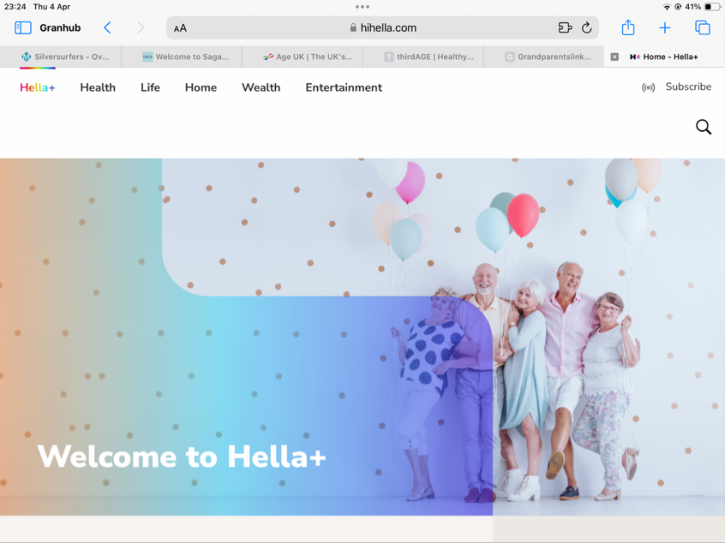

- what they provide
hihella.com or grandparents.com is a website that provides a variety of services and resources tailored to grandparents, providing a range of services and resources to support them in their role as grandparents and enhance their quality of life. Whether it's seeking advice, connecting with peers, finding deals, or discovering new activities.

- SWOT Analysis summary
Pros (S/O)
- Diverse Topics and sessions: it offers a wide range of content tailored to grandparents' interests and needs, including articles, resources, and tips on grandparenting, family relationships, health, travel, and more.
- Community Engagement: The website features a community forum where grandparents can connect with each other, share experiences, ask questions, and provide support. This fosters a sense of belonging and camaraderie among users.
- Exclusive Deals and Discounts: It provides access to exclusive deals, discounts, and special offers from partner brands and businesses, helping users save money on various products and services.
- Contests and Sweepstakes: The website hosts contests, sweepstakes, and giveaways for grandparents, offering opportunities to win prises and rewards, which can incentivise engagement and participation.
- Recipes and Cooking Ideas: It offers a collection of recipes and cooking ideas suitable for families and grandchildren, providing practical resources for grandparents looking to bond with their grandchildren through food.

Cons(W/T)

- Website Design and Navigation: The website's design and navigation may be outdated or cluttered, making it challenging for users to find specific content or navigate the site efficiently.
- Quality Control: It needs to improve user experience and content quality. The quality of content and user-generated discussions in the forums may vary, with some posts lacking accuracy, credibility, or relevance, potentially impacting user trust and satisfaction.
- Limited Personalisation: it lacks personalised content recommendations and user-specific features, which could hinder user engagement and retention by failing to cater to individual preferences and interests.

- Advice for Granhub
- Focus on Forum features and invite the experts to provide high quality articles or blogs on different topics and industries such as pension, gardening, cooking, housing, grandparenting, relationships and so on.
- Create subscription and add email interaction for marketing purpose.

- https://www.gransnet.com
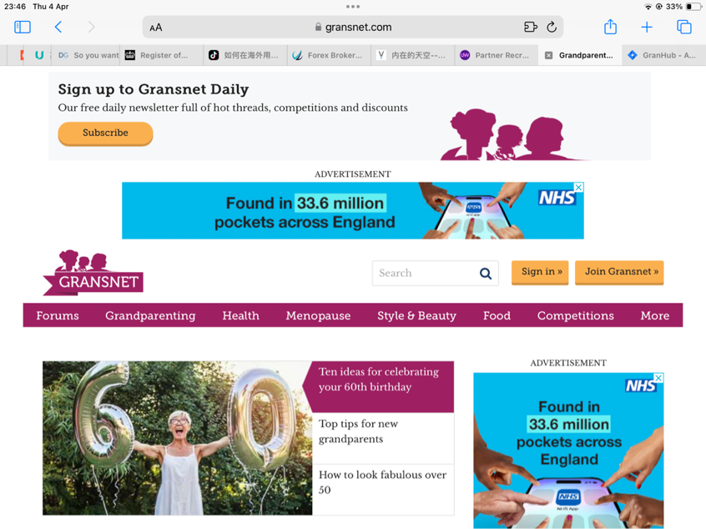
- what they provide
Gransnet serves as a valuable platform for grandparents, offering a combination of community support, expert advice, informational resources, and entertainment opportunities tailored to their needs and interests.
- Community Forums: Gransnet features active community forums where grandparents can connect with each other, share experiences, seek advice, and provide support on a wide range of topics relevant to grandparenting and family life.
- Articles and Advice: The website offers articles, blog posts, and expert advice on various aspects of grandparenting, including tips for bonding with grandchildren, managing family relationships, navigating childcare arrangements, and coping with the challenges of aging.
- Book Club: Gransnet hosts a book club where members can discuss and review selected books, providing an opportunity for literary enthusiasts to connect and engage in discussions about literature.
- Competitions and Offers: Gransnet regularly runs competitions and offers exclusive deals, discounts, and giveaways for its members, providing opportunities to win prizes and access special offers from partner brands and businesses
- Local Information and Events: The website provides local information and event listings, allowing users to discover events, activities, and community resources in their area, as well as opportunities to connect with other grandparents locally.
- Grandparenting Guides: Gransnet offers comprehensive guides and resources on grandparenting-related topics, covering everything from legal rights and responsibilities to tips for maintaining relationships with adult children and grandchildren.

- SWOT Analysis summary

Pros(S O)
- Community Engagement: Gransnet.com excels in fostering a strong sense of community among its users. The website features active forums where grandparents can connect with each other, share experiences, offer advice, and provide support. This sense of belonging encourages user participation and loyalty.
- Relevant Content: Gransnet.com provides a wide range of content tailored to the interests and needs of grandparents. From articles and blog posts to expert advice and user-generated discussions, the website offers valuable resources on topics such as grandparenting, relationships, health, finance, and hobbies.
- User-Friendly Design: The website boasts a clean and intuitive design, making it easy for users to navigate and access information. The layout is visually appealing, with clear categorisation and search functionality, enhancing the overall user experience.
- Inclusivity: Gransnet.com is inclusive of diverse perspectives and experiences within the grandparenting community. The website welcomes grandparents from all backgrounds and family structures, fostering an environment of acceptance and understanding.
- Partnerships and Campaigns: Gransnet.com collaborates with brands and organisations on campaigns, competitions, and sponsored content relevant to grandparents. These partnerships provide additional value to users while also supporting the website's operations.

Cons (W T)
- Content Freshness: While Gransnet.com offers a wealth of content, there could be more emphasis on keeping the content fresh and up-to-date. Regularly updating articles, featuring new discussions, and refreshing resources can help maintain user engagement and interest over time.
- Interactive Features: Introducing more interactive features and tools could enhance user engagement and participation on the website. For example, incorporating quizzes, polls, surveys, or interactive events can encourage users to actively contribute and interact with each other.
- Accessibility: Enhancing accessibility features can make the website more inclusive and user-friendly for older adults and individuals with disabilities. This includes features such as adjustable text sizes, alternative text for images, and compatibility with screen readers.

- Advice for Granhub
By continuing to focus on user engagement, relevant content, and user experience enhancements, we can further solidify our position as a leading destination for grandparents online. And focus on forum feature, add experts, AI and created mobile application if needed.

- other competitors
- https://www.grandparentslink.com
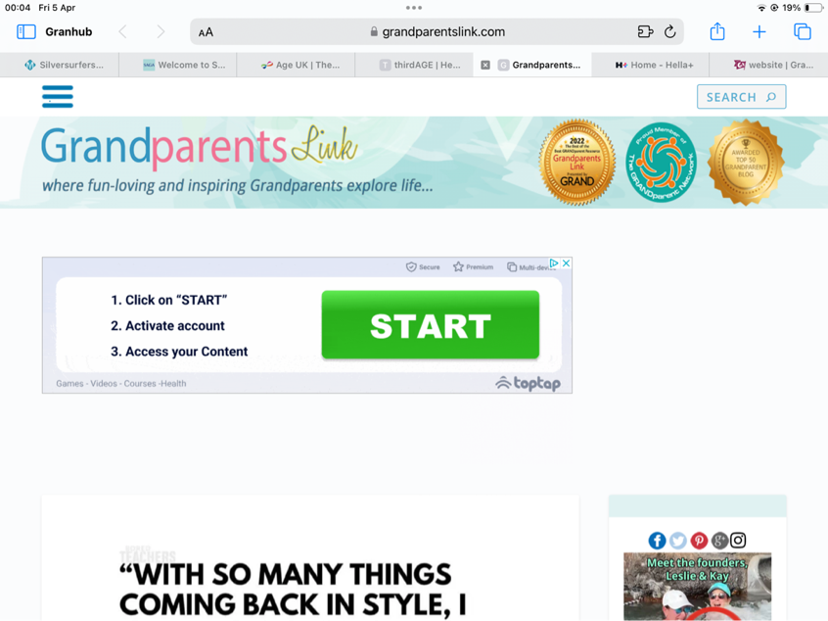
- http://askgranny.com/
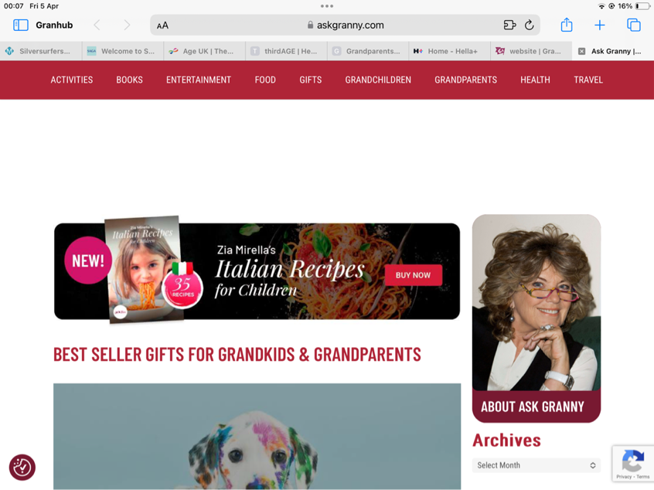
- https://www.aarp.org/relationships/friends-family/?migration=rdrct
